

University of Toronto Mississauga

CSC207 Fall 2022

Design Document

AUTHORS

Raghav Kanda

Ahmed Mohamed

Justin Tran

Christopher Flores



GITHUB TEAM:

MAT102Survivors

GITHUB URL:

https://github.com/o8RaV/MAT102Survivors.git

November 12, 2022

**Contents**

|  |  |  |
| --- | --- | --- |
| **S.No** | **Topic** | **Page Number** |
| **1** | **Title Page** | **1** |
| **2** | **Project Identification** | **2** |
| **3** | **User Stories** | **3** |
| **4** | **Software Design** | **7** |
| **5** | **Expected Timeline** | **9** |

**Project Identification**

For this project, an implementation for the game of Boggle will be created. This implementation will be built using the code base from Assignment 1. By doing so, various features that are absent in Assignment 1 will be created. These features will give the player a more ideal experience when playing Boggle.

For one, the new Boggle implementation will include an attractive GUI. For the implementation in Assignment 1, the player needs to play using the IDE’s console. This is not ideal if they desire a fulfilling experience with the game. After all, most computer games utilize a GUI, which does not require the user to open the code base. Second, the new Boggle implementation will have more features in terms of gameplay. This will make the game more enjoyable for the player since it allows them to customize how they want to play. For example, if the player wants a challenge, then they can enable the option to have a time limit when trying to find words on the grid. Finally, the new implementation will provide additional support for people with disabilities. In the current implementation, the visually impaired may not be able to see the letter grid provided in the IDE console that well, or they may not be able to even see it at all. So, a GUI and an audio interface will be implemented to exemplify accessibility features, such as assistance for the visually impaired.

The User Stories, Software Design, and Expected Timeline to help achieve these goals will be outlined in this document.

**User Stories**

Ahmed Mohamed

Raghav Kanda

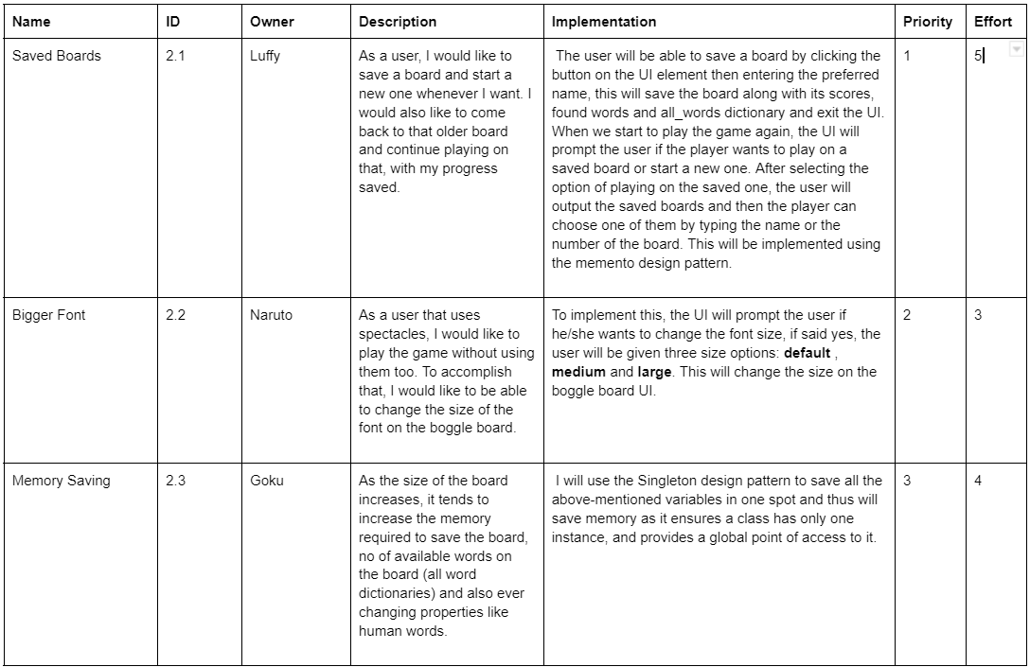

Justin Tran

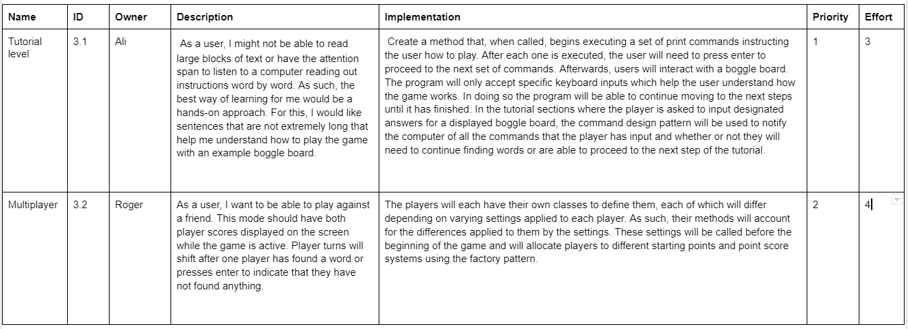

Christopher Flores

